DSA Lab 8
Q1. Write a program to calculate factorial of any given number by using recursion
Source Code
def recur_factorial(n):
if n == 1:
return n
else:
return n*recur_factorial(n-1)

num = int(input("Enter a number: "))

if num < 0:
print("Sorry, factorial does not exist for negative numbers")
elif num == 0:
print("The factorial of 0 is 1")
else:
print("The factorial of",num,"is",recur_factorial(num))
Output
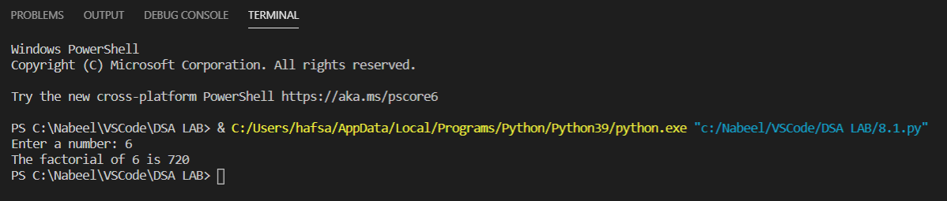

Q2 Write a program to calculate the Fibonacci series of any given number using recursion
Source Code
def recur_fibo(n):
if n <= 1:
return n
else:
return(recur_fibo(n-1) + recur_fibo(n-2))

nterms = int(input("Enter the number of fibinaci terms to find: "))

if nterms <= 0:
print("Plese enter a positive integer")
else:
print("Fibonacci sequence:")
for i in range(nterms):
print(recur_fibo(i))

Output
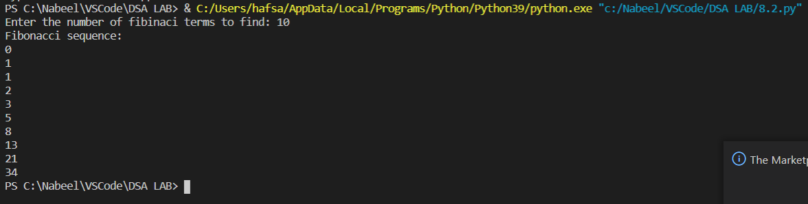

Q3 Implementation of Tower of Hanoi problem using recursion
Source Code
def TowerOfHanoi(n , source, destination, auxiliary):
if n==1:
print ("Move disk 1 from source",source,"to destination",destination)
return
TowerOfHanoi(n-1, source, auxiliary, destination)
print ("Move disk",n,"from source",source,"to destination",destination)
TowerOfHanoi(n-1, auxiliary, destination, source)

n = 4
TowerOfHanoi(n,'A','B','C')

Output
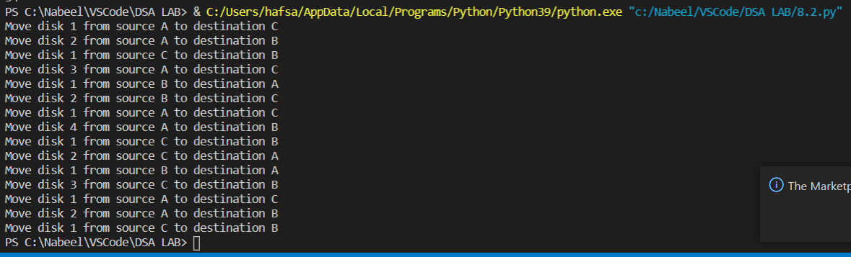

Q4. Implement Binary Search with recursion
Source Code
def binary_search(arr, low, high, x):

if high >= low:

mid = (high + low) // 2
if arr[mid] == x:
return mid

elif arr[mid] > x:
return binary_search(arr, low, mid - 1, x)

else:
return binary_search(arr, mid + 1, high, x)

else:
return -1

arr = [ 2, 3, 4, 10, 40 ]

x = int(input("Enter a number to find in the array: "))

result = binary_search(arr, 0, len(arr)-1, x)

if result != -1:
print("Element is present at index", str(result))
else:
print("Element is not present in array")

Output

